# PUBLIC TRANSPORTATION AND

# OPTIMIZATION.

Team members: Guided by,

1. A.Chinnathai Mrs.S.Vaitheki
2. S.Manjuladevi Assistant proffessor
3. P.Nandhini Dept of ECE
4. G.Swetha

# Objective:

* To introduce computerized transport management systems.
* To ensure mobility of the entire population,including the poor and handicapped;permits computer to reach city centers and assure their viability;contributes to quality of life;and conserves scarce resources such as land and energy.
* It is used ultrasonic sensors to collect the data about vechicle flow and the vehicle’s speed.
* To provide affordable ,safe and sustainable passenger transport services to the public.

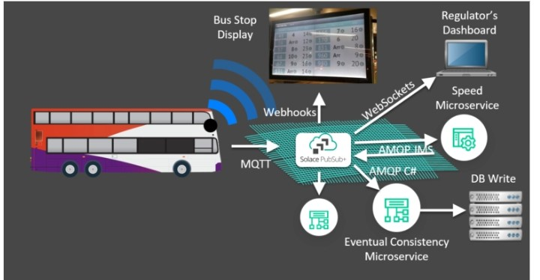

i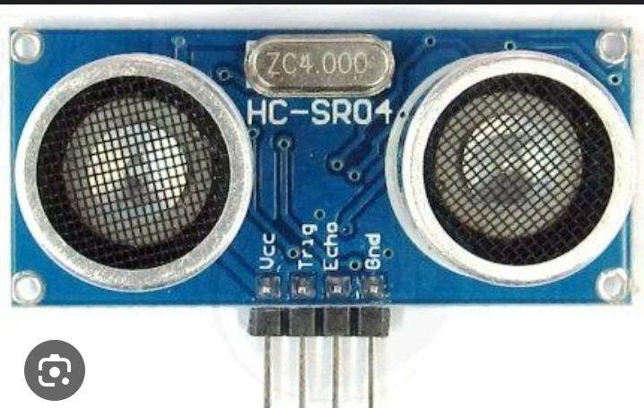

# My Idea For Solving This problem.

* To monitor the transportation using the ultrasonic sensor based on IOT
* Smart transportation is the integration of all these benefits into application for transportation systems.
* Using block diagram we solve the problem of transportation.

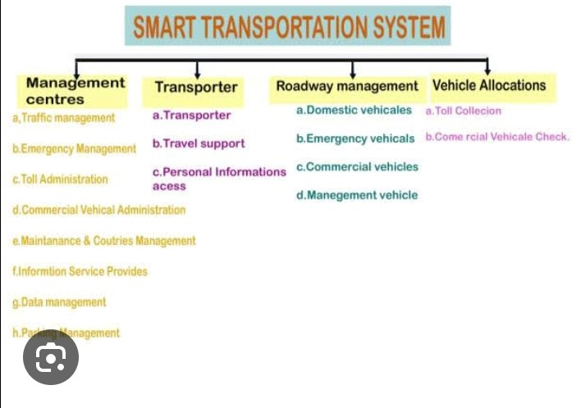

# Block diagram:

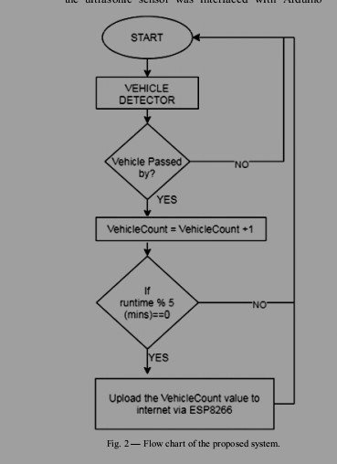

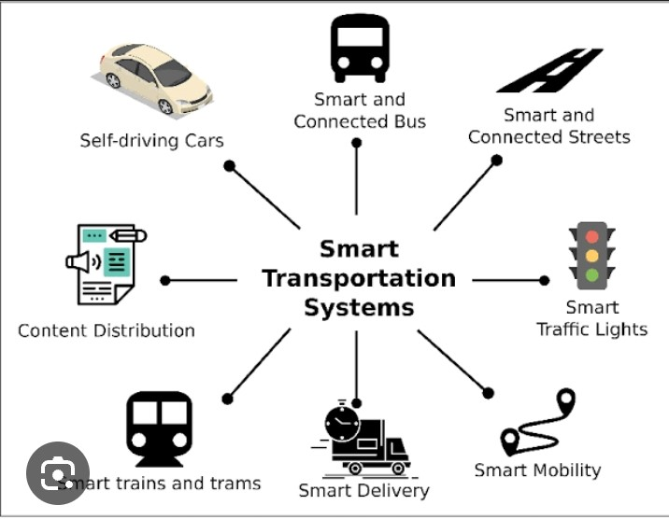

# Key words:

Smart transportation,internet of things,machine learning, intelligent systems,distributed systems,smart transportation application.

Introduction:

